Exam F

QUESTION 1

Which statement is true regarding the COALESCE function?

A. | It can have a maximum of five expressions in a list.
B. | It returns the highest NOT NULL value in the list for all rows.
C. | It requires that all expressions in the list must be of the same data type.
D. | It requires that at least one of the expressions in the list must have a NOT NULL value.

QUESTION 2

View the Exhibit and examine the structure of the PRODUCTS table.

Using the PRODUCTS table, you issue the following query to generate the names, current list price, and discounted list price for all those products whose list price falls below $10 after a discount of 25% is applied on it.

SQL>SELECT prod_name, prod_list_price,
prod_list_price - (prod_list_price * .25) "DISCOUNTED_PRICE" FROM products
WHERE discounted_price < 10;

The query generates an error.

What is the reason for the error?

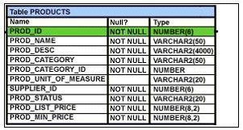

A. | The parenthesis should be added to enclose the entire expression.
B. | The double quotation marks should be removed from the column alias.
C. | The column alias should be replaced with the expression in the WHERE clause.
D. | The column alias should be put in uppercase and enclosed within double quotation marks  in the WHERE clause.

QUESTION 3
Evaluate the following CREATE TABLE commands:

CREATE TABLE orders
(ord_no NUMBER(2) CONSTRAINT ord_pk PRIMARY KEY,
ord_date DATE,
cust_id NUMBER(4));

CREATE TABLE ord_items
(ord_no NUMBER(2),
item_no NUMBER(3),
qty NUMBER(3) CHECK (qty BETWEEN 100 AND 200),
expiry_date date CHECK (expiry_date > SYSDATE),
CONSTRAINT it_pk PRIMARY KEY (ord_no,item_no),
CONSTRAINT ord_fk FOREIGN KEY(ord_no) REFERENCES orders(ord_no));

The above command fails when executed. What could be the reason?

A. | SYSDATE cannot be used with the CHECK constraint.
B. | The BETWEEN clause cannot be used for the CHECK constraint.
C. | The CHECK constraint cannot be placed on columns having the DATE data type.
D. | ORD_NO and ITEM_NO cannot be used as a composite primary key  because ORD_NO is also the FOREIGN KEY.

QUESTION 4
You created an ORDERS table with the following description:

Name Null Type
----------------- ------------- --------------

ORD_ID NOT NULL NUMBER(2)

CUST_ID NOT NULL NUMBER(3)

ORD_DATE NOT NULL DATE

ORD_AMOUNT NOT NULL NUMBER (10,2)

You inserted some rows in the table. After some time, you want to alter the table by creating the PRIMARY KEY constraint on the ORD_ID column.

Which statement is true in this scenario?

A. | You cannot have two constraints on one column.
B. | You cannot add a primary key constraint if data exists in the column.
C. | The primary key constraint can be created only at the time of table creation.
D. | You can add the primary key constraint even if data exists, provided that there are no duplicate values.

QUESTION 5

View the Exhibit and examine the structure of ORD and ORD_ITEMS tables.

The ORD_NO column is PRIMARY KEY in the ORD table and the ORD_NO and ITEM_NO columns are composite PRIMARY KEY in the ORD_ITEMS table.

Which two CREATE INDEX statements are valid? (Choose two.)

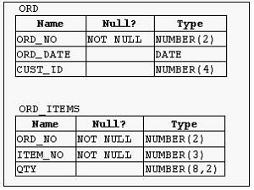

A. | CREATE INDEX ord_idx1  ON ord(ord_no);
B. | CREATE INDEX ord_idx2  ON ord_items(ord_no);
C. | CREATE INDEX ord_idx3  ON ord_items(item_no);
D. | CREATE INDEX ord_idx4  ON ord,ord_items(ord_no, ord_date,qty);

QUESTION 6

View the Exhibit and examine the structure of the PROMOTIONS table.

Using the PROMOTIONS table, you need to find out the names and cost of all the promos done on 'TV' and 'internet' that ended in the time interval 15th March '00 to 15th October '00.

Which two queries would give the required result? (Choose two.)

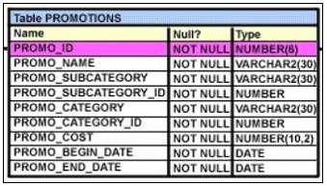

A. | SELECT promo_name, promo_cost  FROM promotions  WHERE promo_category IN ('TV', 'internet') AND  promo_end_date BETWEEN '15-MAR-00' AND '15-OCT-00';
B. | SELECT promo_name, promo_cost  FROM promotions  WHERE promo_category = 'TV' OR promo_category ='internet' AND promo_end_date >='15-MAR-00'  OR promo_end_date <='15-OCT-00';
C. | SELECT promo_name, promo_cost  FROM promotions WHERE (promo_category BETWEEN 'TV' AND 'internet')  AND (promo_end_date IN ('15-MAR-00','15-OCT-00'));
D. | SELECT promo_name, promo_cost  FROM promotions WHERE (promo_category = 'TV' OR promo_category ='internet')  AND (promo_end_date >='15-MAR-00' AND promo_end_date <='15-OCT-00');

QUESTION 7
You need to display the date 11-oct-2007 in words as 'Eleventh of October, Two Thousand Seven'. Which SQL statement would give the required result?

A. | SELECT TO_CHAR('11-oct-2007', 'fmDdspth "of" Month, Year') FROM DUAL;
B. | SELECT TO_CHAR(TO_DATE('11-oct-2007'), 'fmDdspth of month, year') FROM DUAL;
C. | SELECT TO_CHAR(TO_DATE('11-oct-2007'), 'fmDdthsp "of" Month, Year') FROM DUAL;
D. | SELECT TO_DATE(TO_CHAR('11-oct-2007','fmDdspth ''of'' Month, Year')) FROM DUAL;

QUESTION 8
You need to create a table for a banking application. One of the columns in the table has the following requirements:

1) You want a column in the table to store the duration of the credit period.
2) The data in the column should be stored in a format such that it can be easily added and subtracted with DATE data type without using conversion functions.
3) The maximum period of the credit provision in the application is 30 days.
4) The interest has to be calculated for the number of days an individual has taken a credit for.

Which data type would you use for such a column in the table?

A. | DATE
B. | NUMBER
C. | TIMESTAMP
D. | INTERVAL DAY TO SECOND
E. | INTERVAL YEAR TO MONTH

QUESTION 9

View the Exhibit and examine the data in the CUSTOMERS table.

Evaluate the following query:

SQL> SELECT cust_name AS "NAME", cust_credit_limit/2 AS MIDPOINT, MIDPOINT+100 AS "MAX LOWER LIMIT"
FROM customers;

The above query produces an error on execution.

What is the reason for the error?

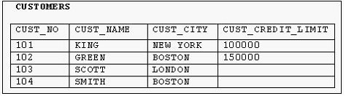

A. | An alias cannot be used in an expression.
B. | The alias NAME should not be enclosed within double quotation marks.
C. | The MIDPOINT+100 expression gives an error because CUST_CREDIT_LIMIT contains NULL values.
D. | The alias MIDPOINT should be enclosed within double quotation marks for the CUST_CREDIT_LIMIT/2  expression.

QUESTION 10

Which statements are correct regarding indexes? (Choose all that apply.)

A. | When a table is dropped, the corresponding indexes are automatically dropped.
B. | A FOREIGN KEY constraint on a column in a table automatically creates a nonunique index.
C. | A nondeferrable PRIMARY KEY or UNIQUE KEY constraint in a table automatically creates a unique index.
D. | For each data manipulation language (DML) operation performed, the corresponding indexes  are automatically updated.

QUESTION 11

View the Exhibit and examine the structure of the PRODUCTS table.

All products have a list price.

You issue the following command to display the total price of each product after a discount of 25% and a tax of 15% are applied on it. Freight charges of $100 have to be applied to all the products.

SQL>SELECT prod_name, prod_list_price -(prod_list_price*(25/100)) +(prod_list_price -(prod_list_price*(25/100))*(15/100))+100 AS "TOTAL PRICE"
FROM products;

What would be the outcome if all the parentheses are removed from the above statement?

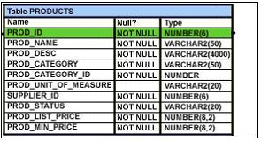

A. | It produces a syntax error.
B. | The result remains unchanged.
C. | The total price value would be lower than the correct value.
D. | The total price value would be higher than the correct value.

QUESTION 12

View the Exhibit and examine the structure of the CUSTOMERS table.

Using the CUSTOMERS table, you need to generate a report that shows an increase in the credit limit by 15% for all customers. Customers whose credit limit has not been entered should have the message "Not Available" displayed.

Which SQL statement would produce the required result?

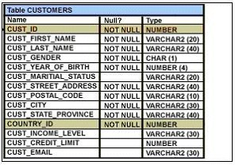

A. | SELECT NVL(cust_credit_limit,'Not Available')*.15 "NEW CREDIT" FROM customers;
B. | SELECT NVL(cust_credit_limit*.15,'Not Available') "NEW CREDIT" FROM customers;
C. | SELECT TO_CHAR(NVL(cust_credit_limit*.15,'Not Available')) "NEW CREDIT" FROM customers;
D. | SELECT NVL(TO_CHAR(cust_credit_limit*.15),'Not Available') "NEW CREDIT" FROM customers;

QUESTION 13

You need to calculate the number of days from 1st January 2007 till date .

Dates are stored in the default format of dd-mon-rr.

Which two SQL statements would give the required output? (Choose two.)

A. | SELECT SYSDATE - '01-JAN-2007' FROM DUAL;
B. | SELECT SYSDATE - TO_DATE('01/JANUARY/2007') FROM DUAL;
C. | SELECT SYSDATE - TO_DATE('01-JANUARY-2007') FROM DUAL;
D. | SELECT TO_CHAR(SYSDATE, 'DD-MON-YYYY') - '01-JAN-2007' FROM DUAL;
E. | SELECT TO_DATE(SYSDATE, 'DD/MONTH/YYYY') - '01/JANUARY/2007' FROM DUAL;

QUESTION 14

Which two statements are true about sequences created in a single instance database? (Choose two.)

A. | The numbers generated by a sequence can be used only for one table.
B. | DELETE <sequencename> would remove a sequence from the database.
C. | CURRVAL is used to refer to the last sequence number that has been generated.
D. | When the MAXVALUE limit for a sequence is reached, you can increase the MAXVALUE limit  by using the ALTER SEQUENCE statement.
E. | When a database instance shuts down abnormally, the sequence numbers that have been cached  but not used would be available once again when the database instance is restarted.

QUESTION 15

View the Exhibit to examine the description for the SALES table.

Which views can have all DML operations performed on it? (Choose all that apply.)

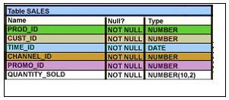

A. | CREATE VIEW v3  AS SELECT * FROM SALES  WHERE cust_id = 2034  WITH CHECK OPTION;
B. | CREATE VIEW v1  AS SELECT * FROM SALES  WHERE time_id <= SYSDATE - 2*365  WITH CHECK OPTION;
C. | CREATE VIEW v2  AS SELECT prod_id, cust_id, time_id FROM SALES  WHERE time_id <= SYSDATE - 2*365  WITH CHECK OPTION;
D. | CREATE VIEW v4  AS SELECT prod_id, cust_id, SUM(quantity_sold) FROM SALES  WHERE time_id <= SYSDATE - 2*365  GROUP BY prod_id, cust_id  WITH CHECK OPTION;

